PLAYLIST
The Playlist
The Playlist in FL Studio sequences (plays) all elements of a project to create the final song. The Playlist window consists of multi-purpose 'Clip Tracks' that can hold Pattern Clips, Audio Clips and Automation Clips. By default, Playlist tracks are not restricted to a single instrument, audio recording, or Clip type (though they can be). This flexibility allows you to place any Clip type anywhere and even overlay Clips. Clips function similarly to notes in the Piano roll. When the play-head reaches a Clip, FL Studio executes the Clip’s instructions, whether it’s playing notes, audio, or automating a parameter.
As Playlist Tracks are not bound to Mixer tracks, the Channel Rack to Mixer routing of Instruments used in Pattern Clips determines the Mixer tracks that are used. By default, it’s Instrument Channels that are bound to Mixer tracks, not the Playlist Tracks. For example, a single Pattern Clip on a single Playlist track could trigger every Channel Rack instrument, and thus all Mixer tracks if they were routed accordingly. This is very powerful, but can be confusing if you are used to other more structured DAWs.
If you want a more traditional 1:1 Instrument Channel --> Playlist --> Mixer relationship, use 'Track Mode'. You can activate this by dropping Instruments or Samples on Playlist Track Headers to create the link between Instrument Channel <> Playlist <> Mixer. Playlist tracks linked this way are known as Instrument Tracks or Audio Tracks, depending on whether the Rack Channel is an Instrument or Audio Clip.

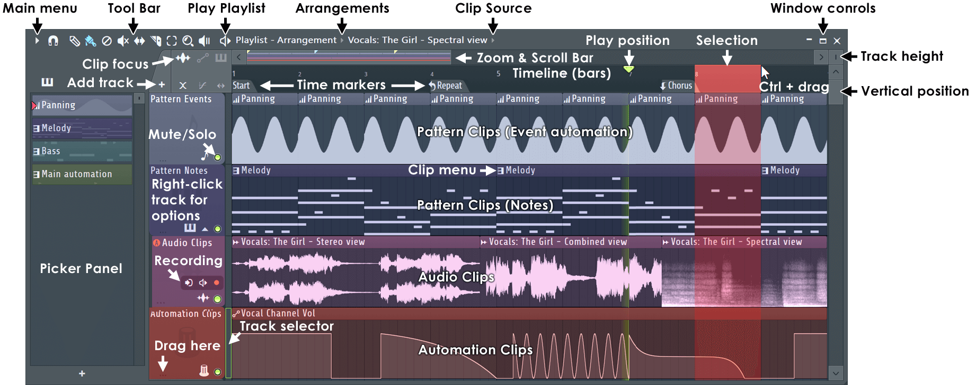
Working with Playlist Tracks
- Track Selector - Playlist tracks are selectable by clicking the selector (see above). Use (Ctrl+Up/Down Arrows) to change the selected track. (Ctrl+Alt/Opt+Up/Down Arrow) to extend the selection.
- Clip Data - Pattern Clips can hold two types of data, MIDI notes and/or controller movements (stored as 'event automation').
- Channel Rack > Playlist > Mixer Linking - Drop instruments on Playlist Track headers to create a link between the three windows. See a video tutorial here.
Playlist Controls
- Tool Bar icons - Along the top of the Mixer window:
 | Playlist Menu - Includes: Edit, Tools, View, Snap, Select, Group, Zoom, Time Marker, Clip Source, Performance Mode, playhead and Detach options.
 | Playlist Snap - Snap determines how Clips will move and quantization aligns events relative to the background grid. For a detailed list of Snap options see the Piano roll menu > Snap section. NOTES: 1. Holding the Alt key temporarily sets snap to 'none'. 2. There is a Global Snap selector on the Snap Panel that is used when this local Snap is set to 'Main'. 3. Scroll speed will slow when snap settings other than 'Line' are used. 4. If items are placing off-grid after changing snap, select them and use the Quantize command (Alt/Opt+Q). This will reset the grid offset of the last touched Clip, which is remembered.
 | Add clips by Draw mode (P) - Left-click to add the currently selected Clip. Left-click-and-drag to reposition the clip before releasing it. Right-Click to delete Clips. Right-Click and drag to delete multiple clips. Right-Click and hold on the background to open the slice tool (F10 > General settings > Click and hold functions on). Modifier keys: (Shift) add in Paint mode. (Ctrl) to make a selection. (Alt) to add in Draw mode with snap set to 'none'.
 | Add clips by Paint mode (B) - Left-click to adds the currently selected Clip. Click-and-drag to paint multiple clips. Right-Click to delete Clips. Right-Click and drag to delete multiple clips. Right-Click and hold on the background to open the slice tool. Modifier keys: (Shift) to copy the selected Clip. (Ctrl) to make a selection. (Alt) and click on a Clip to move it with snap set to 'none'.
 | Delete (D) - Click or Click-and-drag to delete Clips. Modifier keys: Hold (Shift) to make a selection, then press (Delete).
 | Mute (T) - The mute tool mutes individual Clips. This is independent of the Track mute switch which has no effect on Muted Clips. Left-click on clips to mute them. Left-click and drag to mute multiple clips. Right-Click to delete Clips. Right-Click and hold on the background to open the slice tool. Modifier keys: (Ctrl) to make a selection. (Alt) and click on a Clip to move it with snap set to 'none'.
 | Slip Edit (S) - Left-click on the content of Clips to slide them left or right relative to the time-line while retaining the start/end points of the Clip. NOTE: Slip Editing is used where the Clip has been sliced, or resized, shorter than the original length.
 | Slice (C). Click and drag to make vertical slices through Clip OR use (Left-Shift) to Slice diagonally. You can also (Right-Shift) and click on the background grid to switch to the Slice mode without selecting the tool. NOTE: The Settings > Project > Advanced > Play truncated notes in clips option can be useful when slicing Clips. Modifier keys: (Shift) slice without dragging. (Ctrl) to make a selection. (Shift+Alt) Slice without dragging and with snap set to 'none'.
 | Select (E) - Either Left-click on Clips or Left-click and drag to make group selections. Modifier keys: (Shift) add to or remove from selection.
 | Zoom to selection (Shift+Z) - When in Paint mode, use (Ctrl+Right-Click) and drag to make a zoom-to selection. Right-Click again to swap between zoom and unzoomed modes.Right-Click to open a menu of quick zoom options:  - Zoom in/ Zoom out (Page up / Page down) - Zoom centers on the Cursor position.  - Quick-zoom 1, 2 & 3 (Shift+1, 2, 3) - Three handy zoom levels.  - Zoom out (Shift+4) - Switches between 'zoom out' and previous zoom level.  - On Selection (Shift+5) - Zoom to content selection.
 | Play selected (Y) - Click the clips you want to play. Click position will set the start location.
 | Play / Pause - Left-click to start/pauses playback. Right-Click (while playing) to stop and return to the last set start position. Right-Click (while stopped) to return the playhead to the start of the song. NOTE: There is an option on the Right-Click main transport Stop button Remember seek time for the start position to be remembered.
- Playlist Context Tool-Menu - The Context Tool Menu provides local access to the above Icon controls and the Main Menu, without needing to move your mouse away from your point of focus. To open it, use (Middle-Mouse-Click+Right-Click) anywhere inside the Playlist, including on existing content, to show the context menu below.
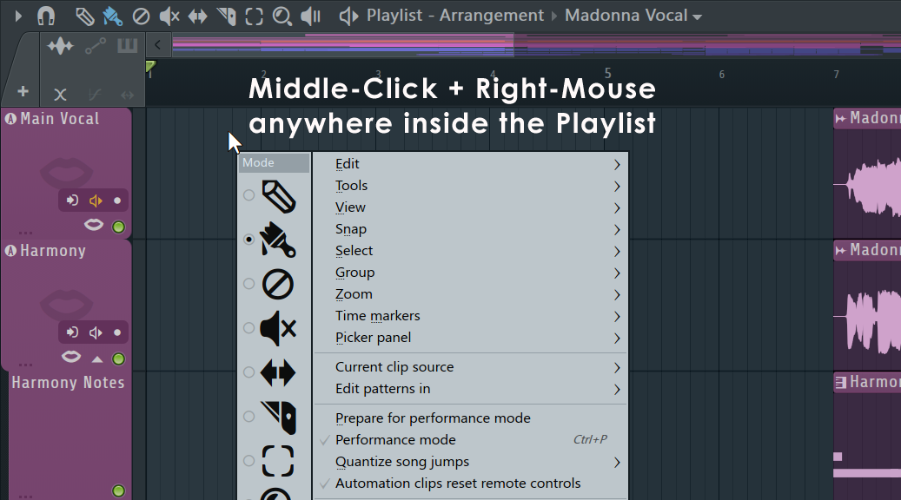
- Arrangements - An 'Arrangement' is the layout of Audio, Automation and Pattern Clips in the Playlist. Use the drop-down 'Arrangements menu' on the Playlist Title Bar to manage multiple versions of the project (working ideas, sound design, versions etc). The menu options include:
  - Clone - Copy the current arrangement to a new arrangement.
  - Rename - Rename the current arrangement.
  - Delete - Deletes the current arrangement.
  - Merge with - Select another arrangement to Merge with the current Arrangement. This will open a pop-up window with more options:
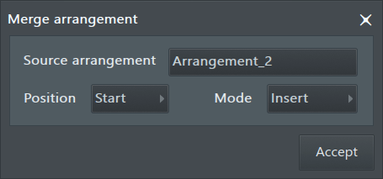
    - Source arrangement - Select the arrangement to be merged into the current arrangement. NOTE: The source Arrangement remains intact after a Merge.
    - Position - Start: Merge from the start of the Playlist, Current: Merge from the start of the current selection, End: Append to the end of the current Playlist data.
    - Mode - Insert: The inserted data moves the existing data to the right. Merge: The merged data is blended with the destination data. Replace: The source data replaces destination arrangement.
  - Add one - Add an empty Arrangement to the project.
NOTES: Arrangements share the Channel Rack and Mixer layout, so be careful not to delete Channels, Effects or Mixer tracks/routing used by other Arrangements. Likewise, don't change level settings of the Mixer or Channel unless you want it to affect all Arrangements.
- Clip Source Menu, Picker Panel and Project Picker (indicated above) - Left-click - The menu at the top of the Playlist shows Clips available to be placed in the Clip Tracks area. Right-Click - to open the Project Picker (Ctrl+F8). Once a Clip is selected it can be added to the Playlist by Left-clicking on an empty Clip Track space. Alternatively Right-Click the Clip Focus icons to see menu-selections of Clips unique to each type.
- Play Position Marker (indicated above) - Displays the current playback position, can be (Left-clicked & dragged). You can Left-click to reposition this marker while the song is stopped or playing. NOTE: There is an option on the Right-Click main transport Stop button Remember seek time for the start position to be remembered.
- Song Loop (uses Time Markers) - Right-Click a Time Marker and select the option 'Song loop'. See below for more information on adding Time Markers. The 'Song loop' marker (note the down facing arrow) defines the repeat point for a playing project, repeats are not played when a song is rendered although the marker can be used to define render length. TIP: The Repeat Marker is ignored during rendering except for the special case where the marker is set beyond the end of the last Playlist data. This will force the project to be rendered to the point set by the marker, useful for ensuring decaying effect sounds are captured. LIVE: The song markers can also be used to control live playback & performance. NOTE: There is a Loop Recording option on the Toolbar shortcut icons.
- Timeline Selection (indicated above) - (Ctrl+Left-click) & drag in the bar-ruler area to make a vertical selection across all tracks. (Shift+Left-click) & drag to copy-move selection. The Timeline Selections will play in loop mode or render as a single section. Actually we cheated a bit with the screen shot, while only the selected portion of the Playlist will play, any portions of a Clip outside the selected area will also turn red (i.e. be selected), but these out-of-bounds clip-parts won't play. NOTE: See here to learn more about using the time-line selections to add or delete time sections of the Playlist.
- Horizontal Zoom / Timeline Zoom (indicated above) - Left-click and drag on the left or right edge of the horizontal scroll handle. Alternatively place the Mouse cursor over the location to zoom and (Ctrl+Mouse-wheel). Maximum Zoom/Snap resolution may be increased by changing the Project Timebase (PPQ) setting (F11), in the General Project settings. The default PPQ should provide adequate zoom/resolution for most projects. NOTE: Click the (Middle-Mouse-Button) and drag in the Playlist to scroll vertically and horizontally at the same time.
- Vertical Zoom (indicated above) - Left-click and drag the track height control up/down to change the vertical zoom of all Playlist tracks. You can resize individual tracks by dragging on the dividers between tracks in the name area (as indicated above 'Drag here'). (Ctrl+Right-Click) on an empty Playlist track area to zoom to full view. (Ctrl+Right-Click) again to return to the previous Zoom and location.
- Window controls (indicated above) - Maximizes/minimizes the Playlist. The playlist can also be detached from the FL Studio desktop from the Main Menu > Detached option.
- Clip Focus & Options Selector (indicated above, top left) - Left-click: each tab to bring that Clip type to the top of any stack that includes Audio, Automation or Pattern Clips. Each tab contains some edit options unique to each Clip type. Right-Click: each tab to select Clips of that category to be added to the Playlist (this is an alternative to the Clip Source menu).
- Time Markers (indicated above) - Add by selecting (Alt/Opt+T) or ' Time markers > Add time marker' . Left-click, hold & drag a marker to reposition it. Once the first Time marker is added to a project, it can be Right-Clicked to Add a new marker, Delete it or Rename. Time markers can also be used for selections & live jumping (see below).
- Track Mute / Solo (indicated above) - Applies to all Clips on the Playlist track/lane.
  - Mute/Unmute - (Left-Click) the Mute icon.
  - Solo/Unsolo - (Ctrl+Left-Click) OR (Right+Click) on the Mute icon. NOTE: The General Settings > 'Restore previous state after solo' option will preserve the pattern of muted and unmuted items prior to a Solo action.
  - Mute/Solo a track group - (Alt/Opt+Click) the Mute icon for any member of the group. Groups are defined by the Right-Click 'Group with above track' option.
  - Lock state - (Shift+Click) a Mute icon.
- Clip Menus (indicated above) - The Clip Menu can be found at the top-left corner of each Clip. Click to open. Options may vary depending on Clip type.
- Clip Tracks - While there are three different Clip types: Audio Clips (holding audio recordings), Automation Clips (automation data) and Pattern Clips (note & event-automation data). You can put any Clip type on any Playlist track, and even overlay Clips of any type. Clip Tracks are not bound to Mixer tracks, Channel Rack to Mixer routing of the instruments used by Clips determines the Mixer track/s that play. Remember, a single Pattern Clip could trigger every Channel Rack instrument, and so all Mixer tracks if they were routed accordingly. To reorder Clip Tracks, hold (Shift+Mouse-wheel) over the Clip Track label area.
- Track divider (where it says 'Drag here' above) - Resize - Click and drag vertically to resize individual tracks. Group tracks - Drag upward (and keep going) until the track groups with the one above. Do the same thing to ungroup a track OR right-click the track header area and select 'Group with above track'. Alternatively (Right-click+G) on the track to group it with the above.
Playlist Track Header Right-Click Menu
Right-Click Track Header Options (indicated below) - Right-Click the area at the front of any Playlist track for the following options:
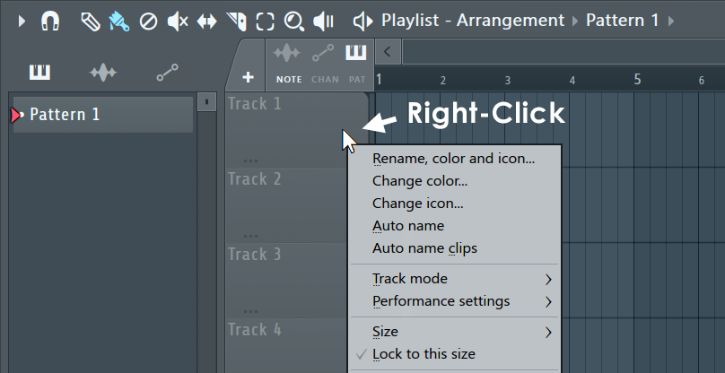
- Rename / color - Renames or re-colors the channel using the Color Selector tool. Click on the Channel name and type to rename, Left-click on the color square (shown below) to open the re-color dialog, or Right-Click to randomly assign a color from a palette pre-approved by the Image-Line Aesthetics Committee. Once the name dialog is open, press (F2) to randomly select colors OR (F3) to select the last used color.
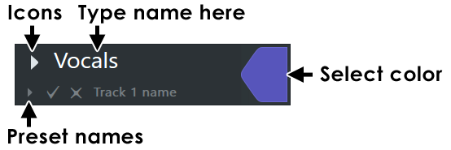
- To Set an icon - Choose from a number of preset icons to display on the Channel button. NOTE: Middle-click on existing icons to directly open the icon menu.
- Auto name - Automatically names and colors the track after the first Pattern Clip in the track.
- Auto name clips - All Clips are renamed and colored based on the Track's name and color.
- Reset - Resets the Track Color, Name and Icon to the default.
- Track Mode - Speed workflow by grouping a Channel Instrument, Playlist Track and Mixer track so changes to the name, color and or icon of any member in the group will ripple throughout the chain.
To create a group - Right-Click Playlist Track headers and choose Instrument or Audio track. Subsequent pop-ups will allow you to choose an Instrument or Mixer destination. Alternatively drop plugins or audio files on Playlist Track headers for even faster workflow. A default Pattern will also be created for Instrument tracks.
Track mode icons - The following icons will appear on all components of an Audio track or Instrument track groups:
N/A | Unassigned - The track has no associations. Use this to disassociate a linked Playlist Instrument or Audio track. Also, see 'Instrument and Audio Track Mixer routing' below. This also allows you to go back to FL Studio's original free workflow where Playlist Tracks are not associated with any Clip type or Mixer Track.
 | Audio track - An Audio Track is defined when a Playlist Track is linked to a Mixer Track. This link changes how Audio Clips dropped on the track OR recorded Audio through the Insert Mixer track will behave:  - Audio Clips - Drop an audio file on a Playlist track to link it with a Mixer track OR Right-click a Playlist track header and choose an existing Audio Clip. Changes to the name, icon or color (Channel, Playlist Track, Mixer Track) will ripple throughout the chain. NOTES: See the Playlist Menu > Edit > Drop audio on track headers options to set the default behavior when dropping Audio files on the Playlist Track headers. Hold (Shift) when dropping multiple files on a Mixer track (not the header) to add them sequentially in the Playlist Track.  - Mixer Tracks - Selected Mixer tracks can be linked to auto-created Audio Tracks with '(Right-click) > Assign to new audio track(s)'.  - Audio recording - (Right-click) a Playlist Track to associate it with a Insert Mixer track. All audio recorded from this Mixer Track will be placed on the selected Playlist Track. If there is no room, sub-track/s to the parent will be created to hold the Audio Clips. NOTE: The (A) icon will turn red when the Mixer Track is armed for recording and the following on-track controls will be available (left to right):  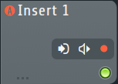  - Select audio input - Choose an Audio Input as per the Mixer Track Input Menu.  - Recording location & Monitor options - As per the Mixer Track Panel options.  - Arm recording - Arms the linked Mixer Track for recording.
 | Instrument track - An instrument track is defined when a Channel Instrument is linked to a Playlist Track. Drop plugins on the Playlist Track header OR Right-click a Playlist Track header and choose a plugin instrument to associate with the track. This will link the Instrument Channel, Playlist Track (including a default Pattern) through to a Mixer track. Changes to the name, icon or color of any member (excluding the Pattern) will ripple throughout the group. The Playlist Track will be locked to the auto-created Pattern (although you can manually add other Clips).  - Open the plugin - Double-Click the Playlist Track header.  - Deleting - If you delete the Channel or Playlist Track there will be an option to delete everything associated with the Instrument.  - Add plugins without opening the interface - Hold Shift to stop the plugin opening when dropping plugins on Track headers.  - Add an existing Instrument Channel - Right-click the Playlist Track and choose 'Track mode > Instrument track > Use existing > ...'. If you do this from a Playlist Track that is already named and colored, this will be preserved, along with the linked Mixer track name and color.
Working with Instrument / Audio Tracks:
  - Hold (Shift) when dropping plugins on track headers to prevent the Plugin GUI from opening.
  - Hold (Shift) when dropping multiple files on a Mixer track (not the header) to add them sequentially in the Playlist Track. This also works for standard Playlist Tracks.
  - Drop Effects plugins on Instrument and Audio Playlist Track headers to add them to the linked Mixer Track.
  - Dropping Effects on one of a multi-selection of Instrument Tracks will add the Effect to all selected tracks in the group.
  - Edit patterns in Piano roll - Double-Click on Pattern Clips to open the Piano roll. NOTE: Use the 'Edit patterns in' option to change this.
  - Open the Piano roll from a Clip - (Double-Click) a Pattern Clip to show the Piano roll. Hold (Alt) to show the Channel Rack. NOTE: Use the 'Edit patterns in' option to change this.
  - Open the Channel Rack from a Clip - Use (Alt + Double-Click) on a Pattern Clip to open the Channel Rack and Instrument. Don't hold (Alt) to show the Piano roll. NOTE: Use the 'Edit patterns in' option to change this.
  - Edit patterns in Channel Rack - Double-Click on Pattern Clips that conatain only Stepsequencer data.
  - Instrument and Audio Track Mixer routing - Instrument Track Channels stay linked to the selected Mixer Track as the routing selector is changed. The selector dims to indicate that it is part of a grouping. Mixer Tracks then move instead of re-routing when the control is adjusted. When grouped, routing automation is not possible. To re-route an Instrument or Audio track group, first Right-click the Playlist Track header and choose Track mode > Unassigned, then to re-route the Instrument Channels as needed. Audio Track Audio Clips will re-route.
- Dropping multiple files - On Track Headers will create multiple tracks. NOTE: The action depends on the Playlist Menu > Edit > drop... options. On Playlist tracks - Hold (Shift) to add files sequentially in the Playlist Track.
- Performance settings - Performance mode must be selected for these to be available.
- Size - Select a default height for the Clip Track in percent. This allows relative scaling to the other tracks. TIP: To reset a track height (Alt/Opt+Click) on a track resize handle/divider.
- Lock to this size - Prevents the Clip Track's vertical height rescaling.
- Group with above track - Makes the Playlist track a sub-track of the one above it. All tracks in a group can be soloed/muted by acting as follows for any member of the Group: (Alt + Right click) Toggles solo for the grouped tracks. (Alt + Left click) Toggles mute for the grouped tracks. NOTE: In the case of Instrument or Audio Tracks, this action will also auto-color the Track with the parent.
- Auto color group - Sets all tracks in the group to the same color as the track that was used to open this menu.
- Lock to content - Locks the Playlist Tracks to the first Clip added to the track OR if Clips are already present, the most common Clip on the track. Clicking on the track will then always add that Clip to the track. NOTE: Older projects made using the legacy Pattern Block tracks are loaded with each Clip track locked to a specific Pattern number, so that Clip tracks behave in the same manner as Pattern Block tracks did. See the  From Blocks to Clips video tutorial.
- Merge pattern clips - Merges the Pattern Clips on the Clip Track into a single Clip.
- Send pattern instances here (Legacy projects only) - When converting a Block Track project to the Clip based format, this option moves selected Pattern instances to the selected track.
- Consolidate track/s (freezing) - Converts all Pattern and Audio Clip/s on each selected track/s to an Audio Clip and mutes the source Clips. The new Audio Clip is routed to the Master Mixer Channel. By default, all Channel Instruments / Audio Clips are captured through their respective Insert Mixer Channels, with FX but without Master FX (so the Master FX are not applied twice). You can change these settings at the Render Dialog pop-up that appears to confirm the action. There are two length options:
  - From track start (Ctrl+Alt/Opt+C) - Consolidated Audio Clip starts at the first Clip in the track.
  - From song start (Ctrl+Alt/Opt+Shift+C) - Consolidated Audio Clip starts from the beginning of the Playlist. Use this method when you are creating song-length 'stems' to share with other projects. There will be no confusion where the Clip should be placed (at the start of Bar 1).
NOTE: You can use this feature to merge vocal or instrumental recordings into a single Audio Clip, or to reduce CPU load (disable Mixer Insert FX not in use afterward).
- Mute all clips / Unmute all clips - This mutes and unmutes Clips on the Playlist track as per the Mute Tool. This is not related to the track Mute switch. Use this feature to quickly unmute Clips that have been muted by a Consolidate function (see above).
- Insert one/ Delete - Inserts a Clip Track or deletes the selected Clip Track.
- Clone... - Duplicate existing Playlist track, with the pop-up option to clone Patterns, Audio Clips, Automation, Effects (in linked Mixer tracks) and Grouped Playlist Tracks. To clone multiple Playlist Tracks use 'Tools > Clone selected playlist track(s) (Shift+Ctrl/Cmd+B). Alternatively you can (Right-Click) the Track Header and use 'Clone track' for individual Playlist Tracks.
- Move up/ Move down - Moves the selected track up/down the stack. Alternatively use (Shift+Mouse-wheel).
NOTE: Drag an audio file (from the Browser, for example) and drop it on the Track label area to auto-create an Audio Clip and auto-name the Clip track to match the file.
Timeline, Time Markers & Time Signatures
Time is displayed horizontally in the Playlist (in bars displayed along the top of the window). The grid resolution is determined by:
- The window's 'Snap' value (). Alternatively, select 'Main' to apply the global snap value (for all windows where snap applies) defined in the Global Snap panel.
- The Horizontal zoom. That is, the snap resolution increases as the Playlist is zoomed in, until it reaches the maximum set by the Snap value. Note how Playlist vertical grid-lines increase as the Playlist is zoomed.
- The Project 'Time Signature' (F11) setting. When 'Time settings > Set as time signature' is selected the grid will reflect the set Time Signature. When 'Time settings > Set as time division' the grid will be 4/4. This was the default prior to the introduction of Time Signatures. NOTE: Time Markers (Shift+Alt/Opt+T) can also set the Time Signature from a selected point or over a range (use a selection).
